DYNAMIC ROUTING RIP (V1/V2)

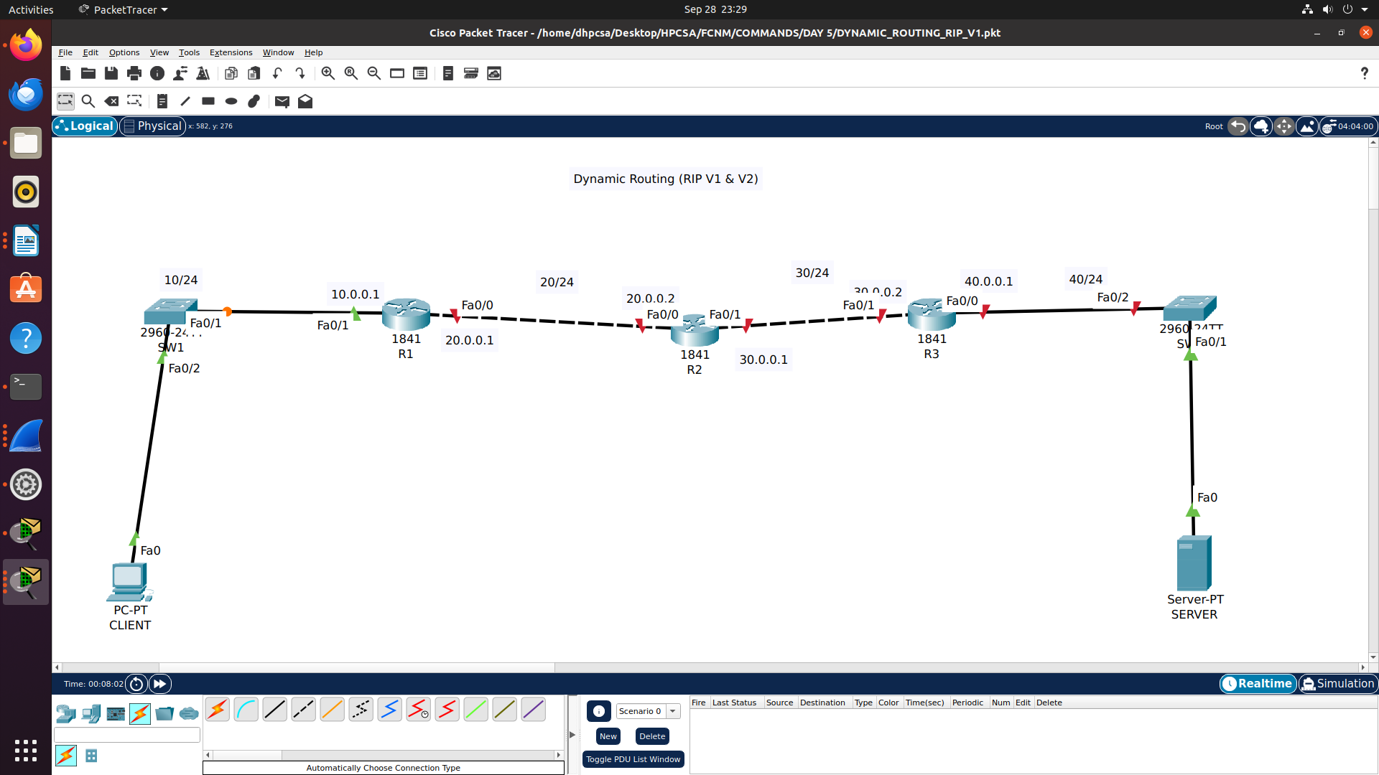

R1(config)#router rip
R1(config-router)#network 10.0.0.0
R1(config-router)#network 20.0.0.0

R2(config)#router rip
R2(config-router)#network 20.0.0.0
R2(config-router)#network 30.0.0.0

R3(config)#router rip
R3(config-router)#network 30.0.0.0
R3(config-router)#network 40.0.0.0

